**Maven:**

Maven is a project management tool. Using Maven you can Validate the code of your project, compile the code, run tests, generates the jar/war/ear files and deploys them the server.

Maven’s Life Cycle:

The first thing you have to know about maven is its life cycle. It’s life cycles consists the following phases.

1. Validate
2. process-resources
3. Compile
4. Test
5. Package
6. Verify
7. Install
8. Deploy

Validate – Checks if a project is correct and all information is available.

Resources – Downloads all the needed repositories and keep them in “.m2” local repository.

Compile – Compile the code (.class files will be generated)

Test – Run the unit tests/TestNG tests

Package – Bundle the package (a jar/tar/war file will be created)

Verify – Run any checks on the results of the tests to ensure quality criteria is met

Install – Generate the artefact (The result of the package) and keep it in local repository (.m2 folder)

Deploy – Upload the artefact into remote repository (Nexus)

**Maven Commands:**

mvn validate – runs the validate command to check if a project is correct and all information is available

mvn process-resources – runs the command to check if the required resources are there or not. If not it will download the resources from maven repository into the local repository which is .m2 folder.

Note: maven repository is a public repository where people upload their repositories and maven will download the required repositories from there. We will discuss the repositories (dependencies and plugins) required in the maven xml section.

Maven repository: <https://mvnrepository.com/>

mvn compile – This command will compile and generate class files.

mvn test – This command will run the tests like Junit tests or TestNG tests.

mvn package – This command will generate the jar files.

mvn verify – This command verify the tests that were run and checks if the required quality criteria is met.

mvn install – This keeps the generated artefact from package command and stores it in local repository (.m2 folder)

mvn deploy – It deploys the generated jar files/war files into remote repository or server.

Maven works in hierarchical model. That means when you run any commands above, it runs all the previous commands as well starting from validate.

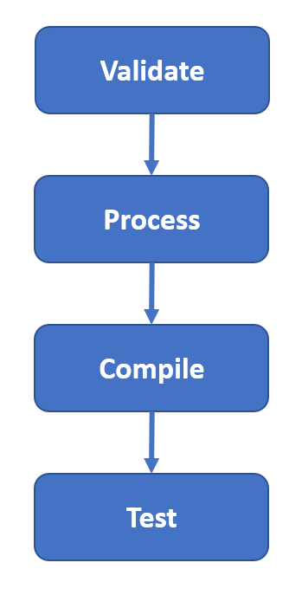

For running our selenium tests we directly use “mvn test” command.